93-00 Subaru Impreza 02-12 WRX / STi
Urethane Transmission Crossmember Bushing Set
Tools required:
3/8” 14mm Deep socket
3/8” Ratchet
3/8” Torque wrench
Socket extension optional
Jack and Jack stands or Lift

- Lift the vehicle if using a lift, if using jacks park the vehicle on a level surface and support with jack stands.

- Remove the 4 transmission crossmember bushings and the 2 transmission mount bushings.
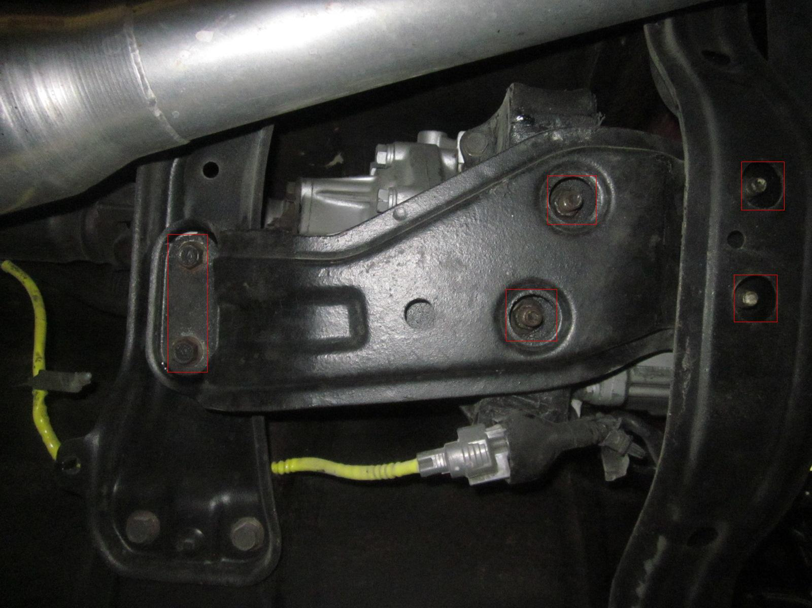

- Remove the Transmission crossmember by dropping the back down and lifting up the front.
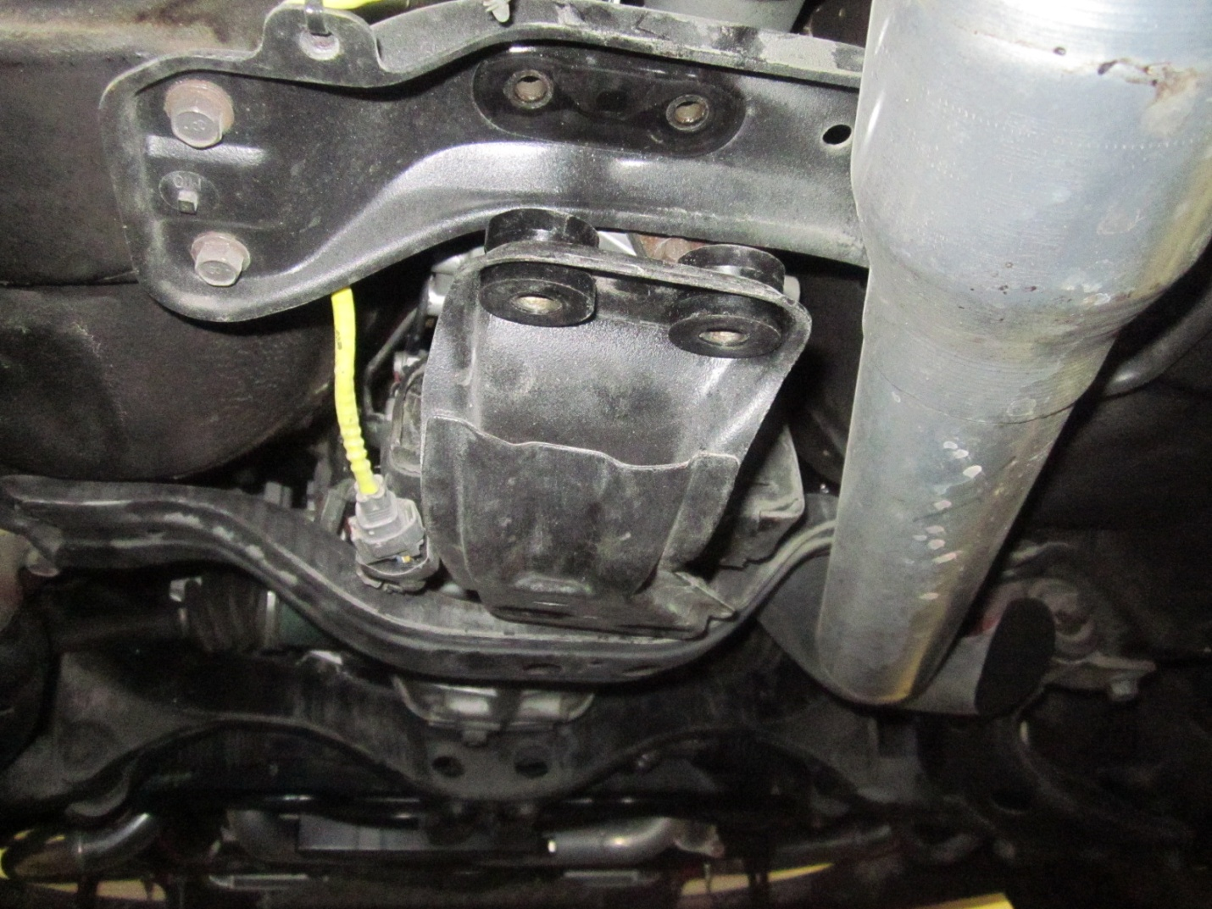

- Remove the crossmember from the vehicle.
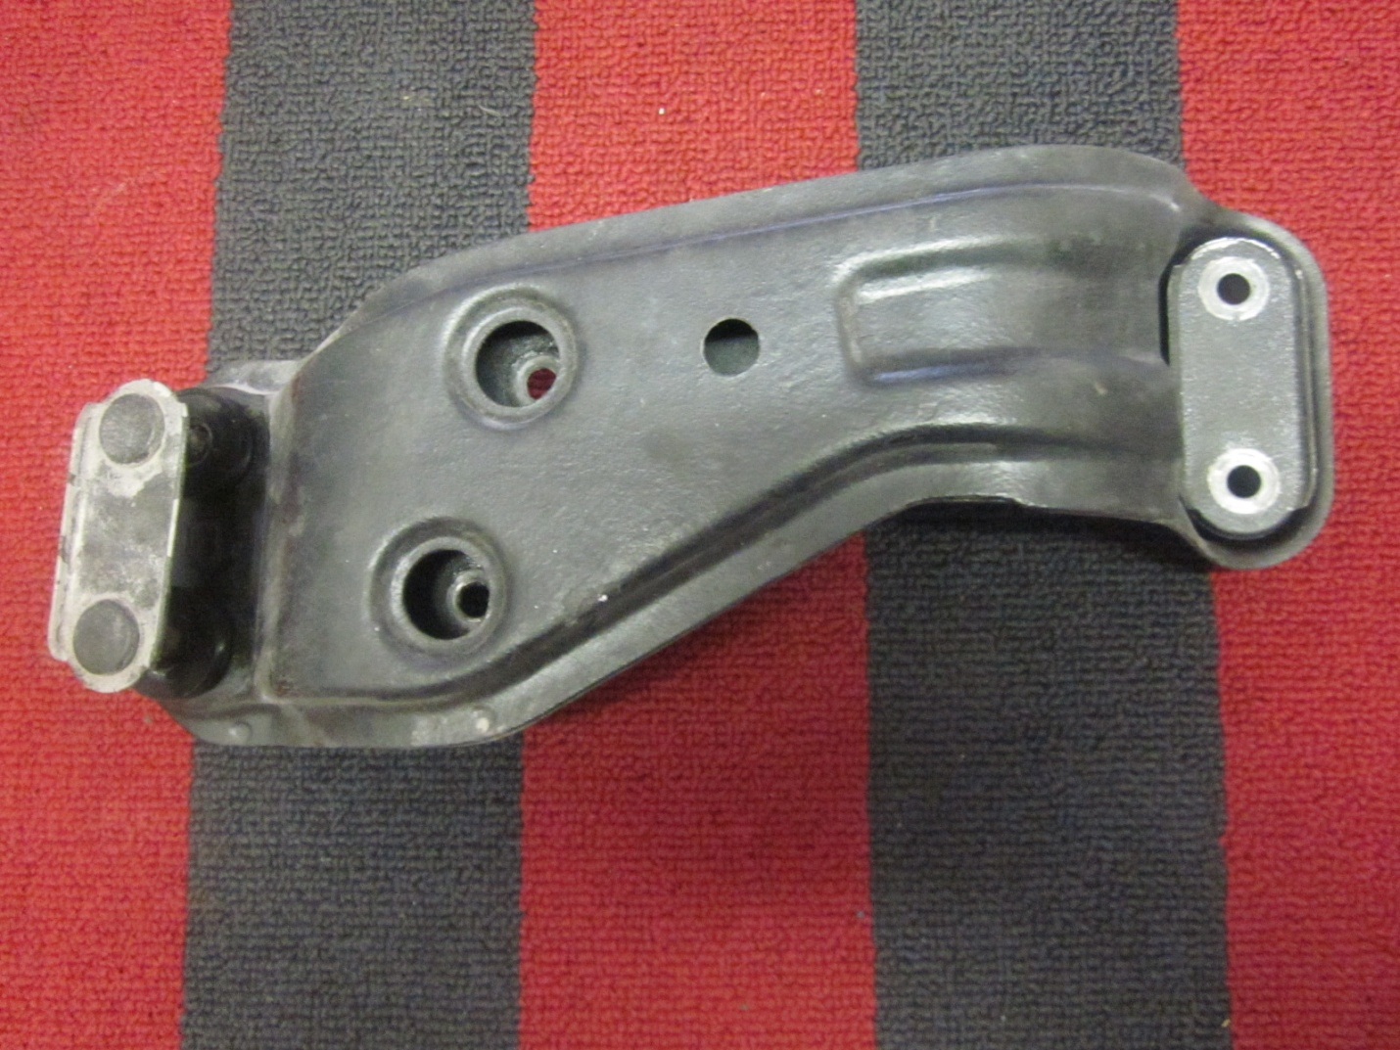

- Remove the old bushings by pulling them apart.
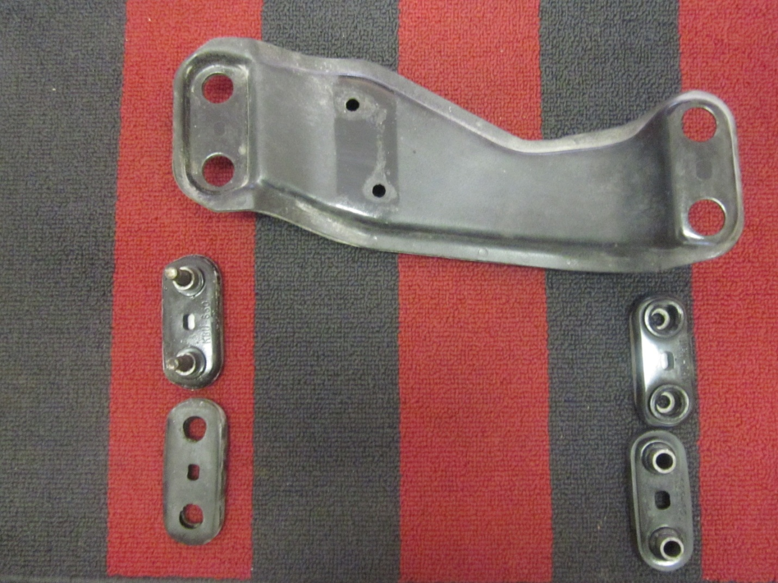

- Remove the dowel pins from the old bushings and install them into the new bushings. Take note that 4 of the bushing have a lip to them and the other 4 do not.
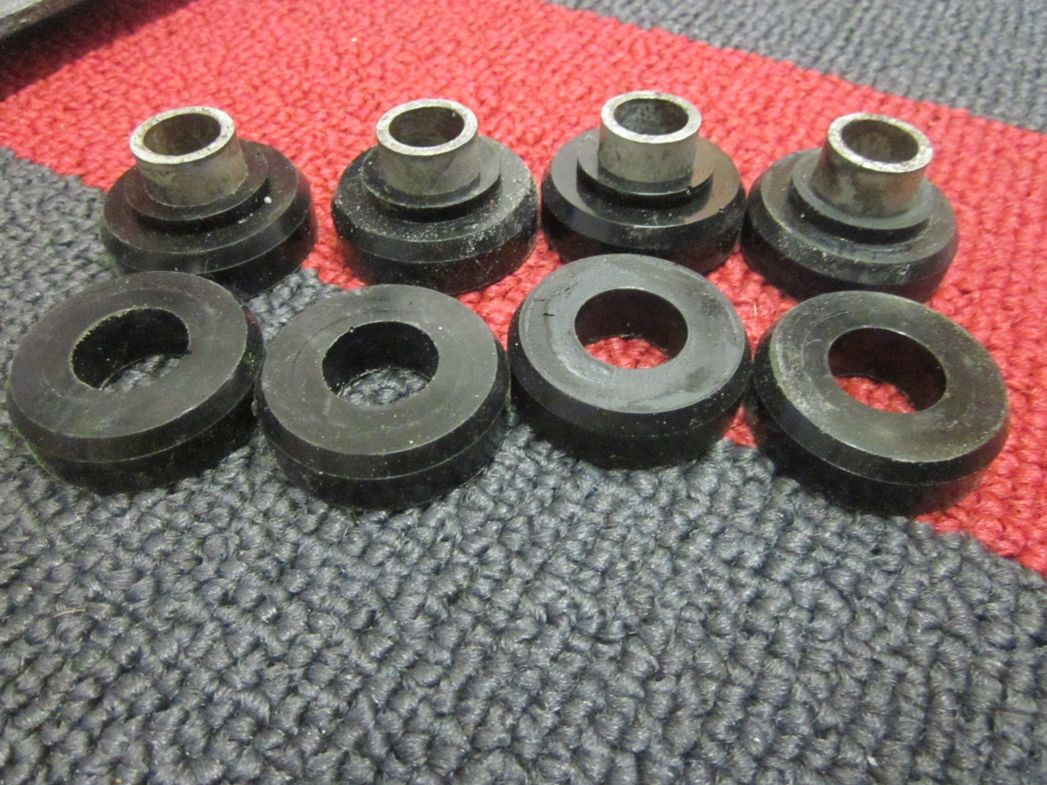

- Install the bushings into the crossmember. Matching them up in pairs of ones with a lip and ones without.
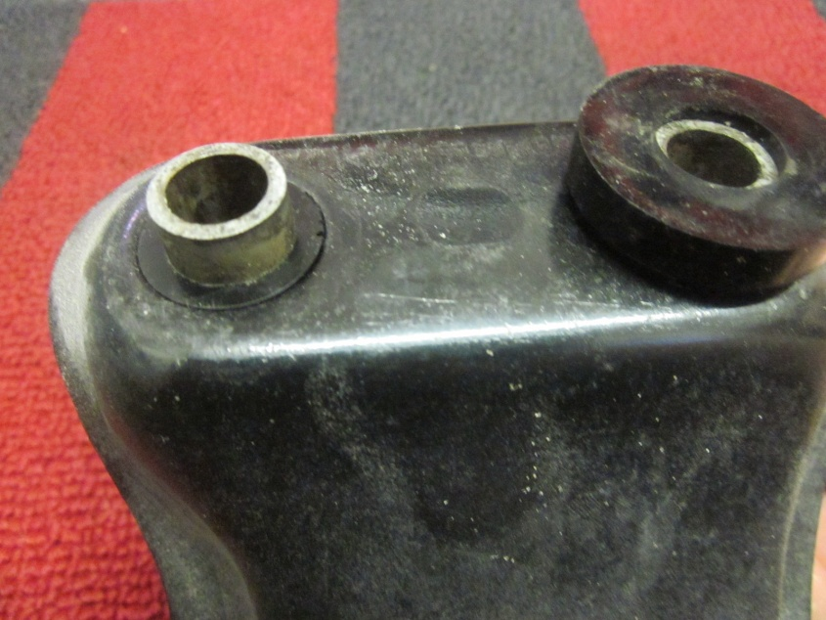
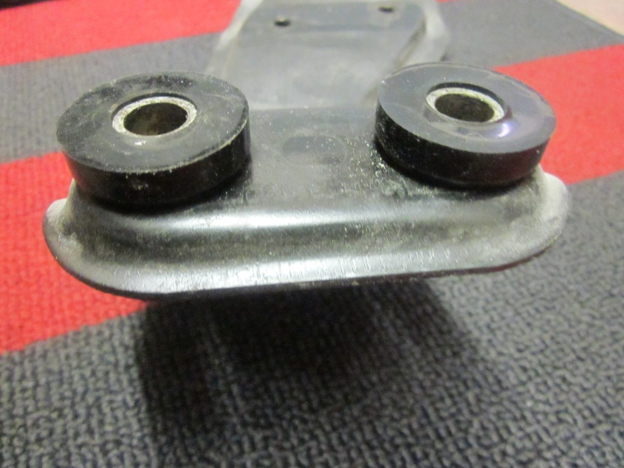

- Reinstall crossmember and torque all bolts to 27ftlbs

